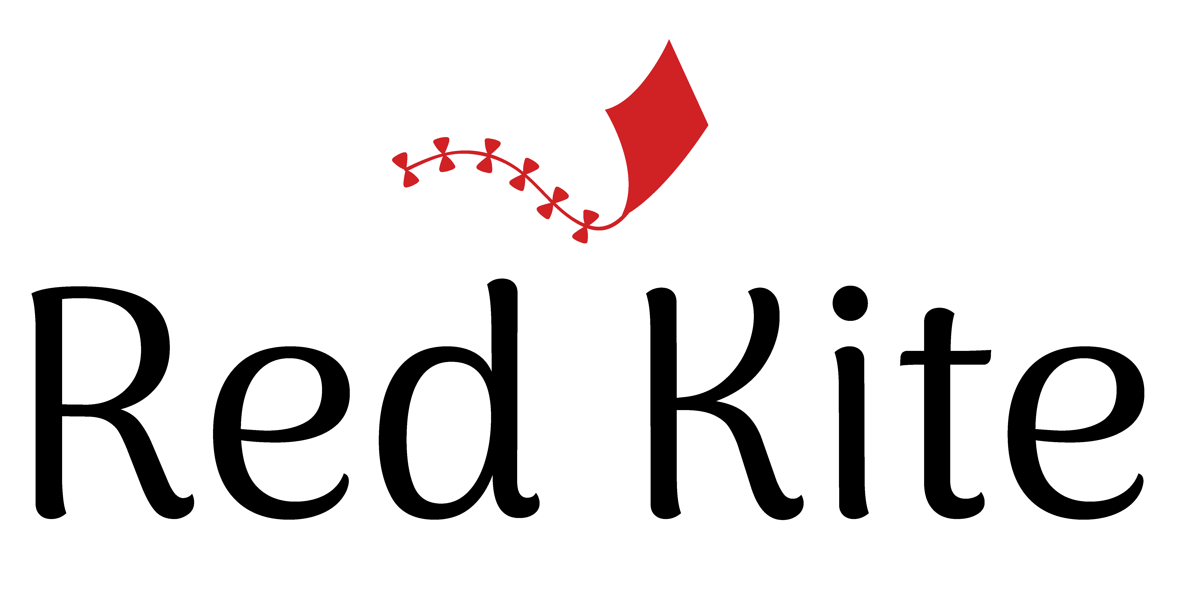
Positive Guidance policy
Rationale: Children will experience an environment in which they learn the limits and boundaries of acceptable behaviour. Adults will teach acceptable behaviour using a variety of strategies, and will always treat children and their families with respect. Red Kite rules will be based on respect for self, respect for others and respect for our equipment and facilities.
Procedures:
- Staff will receive professional development and support as their teaching practice evolves. Through mentoring and professional development, the teaching team will constantly strive to develop and improve responses to children’s behaviour.
- Staff will at all times maintain a calm and positive atmosphere in the teaching environment. This will be done using strategies including attention to the levels of ambient noise, management of group play and ensuring adequate resources are available to engage the children in productive play.
- Staff will ensure that their interactions with children are positive in nature, treating mistaken behaviour as opportunities to teach correct behaviour. Children may be redirected to a different activity or as a last resort equipment or toys may be removed.
- Staff will at no time use harsh or belittling language towards children, nor will they raise their voices towards children.
- Staff will model courteous behaviour to the children in their interactions with other staff and family members.
- When intervening in conflict between children, staff will have regard to the developmental level, temperament and individual circumstances of each child. Children will be encouraged to find their own solutions where appropriate. Emphasis will be placed on restoring relationships through offering apologies or hugs.
- Very inappropriate behaviour which poses a danger to the child or those around them may result in the child being removed from the immediate area along with a teacher who will stay with them until they are able to self-regulate. The teacher will use the opportunity to talk to the child about their behaviour in a calm and kind manner.
- Dealing with challenging behaviours can be stressful. Staff are strongly encouraged to seek assistance from other team members if they are having difficulties.
- Staff are discouraged from imposing unnecessary rules on the children. Rules should be reserved for times when there is a genuine risk of harm or disruption to those nearby, or damage to equipment.

November 2018. C10

